**A**

**Project Report**

**Submitted in partial fulfillment of the**

Bachelor of Computer Application

**MAHATMA JYOTI RAO PHOOLE UNIVERSITY, JAIPUR**

**On**

**“Heart Risk Prediction”**



**Submitted By**

**Student Name: Tanushree Nagar**

**Enrollment No: MJRPU/18/023076**

**Roll No: 22564**

**MAHATMA JYOTI RAO PHOOLE UNIVERSITY, JAIPUR**

**Department :- Computer Science & IT**

1. **Project Title : Heart risk prediction**
2. **Software Base : Front End, Back End**
3. **Submitted For Course and Year : B.C.A & 2021**

**CERTIFICATE**

This is to certify that this project entitled **Heart risk prediction**, submitted in partial fulfillment for the Award of **Bachelor of Computer Application** to Mahatma Jyoti Rao Phoole University, Jaipur through Mahatma Jyoti Rao Phoole University done by Ms. Tanushree Nagar, Roll No. 22564 is an authentic work carried out by her under my guidance. The matter embodied in this project work has not been submitted earlier for award of any degree or diploma to the best of my knowledge.

**Signature of the Guide**

**DECLARATION**

This is to certify that the project report entitled **Heart risk prediction** is done by me is an authentic work carried out for the partial fulfillment of the requirements for the award of degree of **Bachelor of Computer Application**. The matter embodied in this project work has not been submitted earlier for award of any degree or diploma to the best of my knowledge.

Signature of External Examiner : Signature of Internal Examiner :

Signature of the student :

Name of the Student : Tanushree Nagar

Roll No. : 22564

Enrollment No : MJRPU/18/023076

**ACKNOWLEDGEMENT**

I find great pleasure in expressing our deep sense of gratitude towards all those who have made it possible for us to complete this project with success. We would first of all like to thanks to Dept of Computer Science & IT to make a project in the Esteemed Organization. I would like to thank the persons whose contributes in my project are immense. I would like to thank **Anju mam**  who helped me during the project for providing me the specific guidance in Project whenever needed .

**Tanushree Nagar**

**Contents**

* **Introduction**
* **Tools used**
* **Projects Requirements**
* **Features**
* **Screenshots**
* **Code written**
* **Future Scope**

**INTRODUCTION**

The main aim of this project is to create a responsive and dynamic web app that will be used to predict risk of heart rate in any individual by using latest technologies with every kind of functionality with great efficiency to make it attractive and easy to use .

**TOOLS USED**

1. Languages used: Python, HTML, CSS
2. Python web development libraries : flask.
3. Python basic data science libraries : numpy, pandas
4. Python machine learning libraries: sklearn
5. Last basic python library used : joblib (for algorithm loading)

**Project Requirements**

* **For end users**
* Operating system (any)
* Any web browser (eg google chrome)
* Proper network connectivity
* **For project part**
* Any best text editor for coding (ex:- notepad++ , visual code)
* Best Knowledge of Python, and web designing.
* Web browser to run the project.
* Python joblib library for loading the project
* Python flask library for deployment of machine learning model.
* **For hardware part**
  + 1 GB RAM
  + 5 GB storage minimum
  + i7 processor
  + Proper internet

**FEATURES**

* + - Totally secure.
    - Easy to use for clients.
    - 90% accurate.
    - Not exorbitant
    - Can be available in zip format.

**Snapshots**

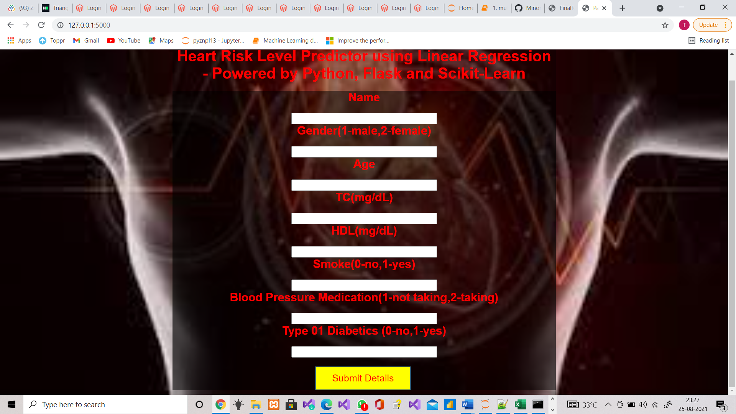

**Home Page(1)**

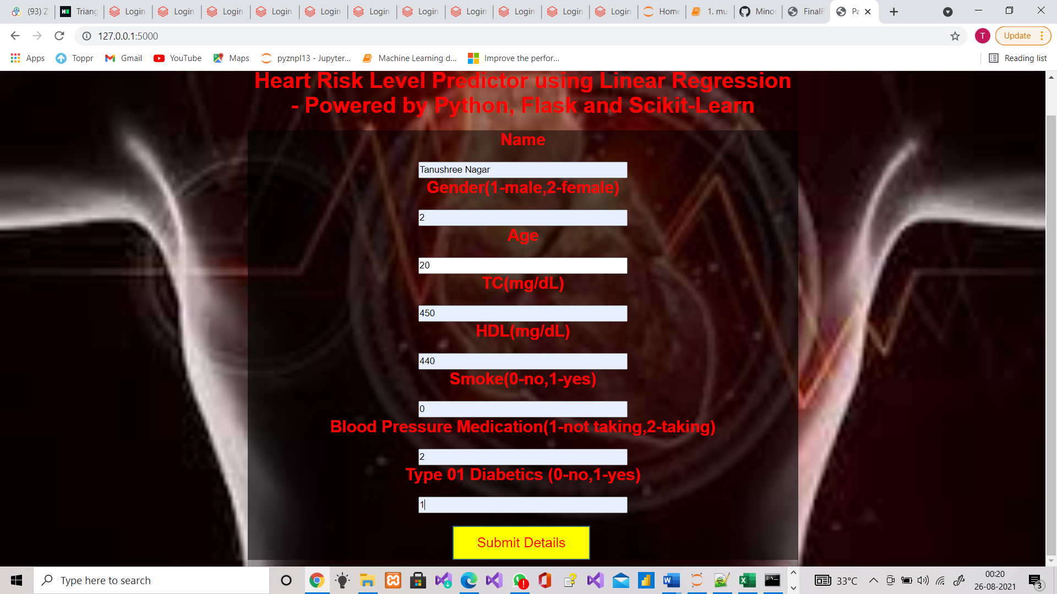

**Home Page(2)**

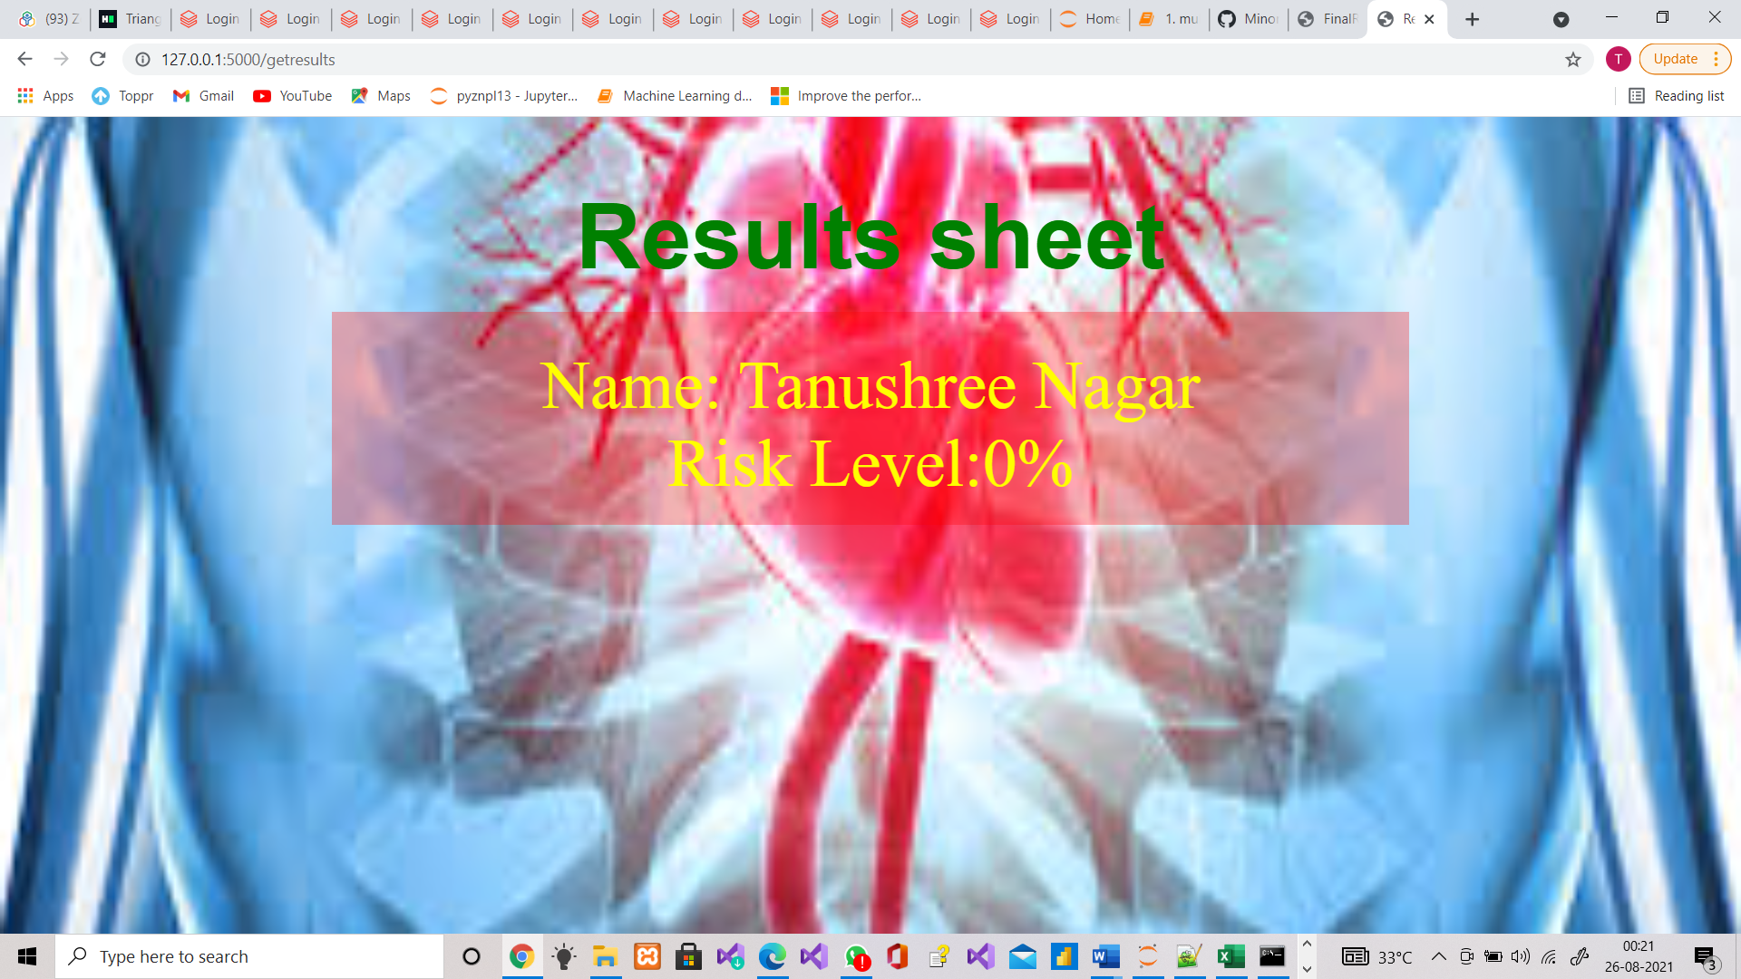

**Result Page**

**SOURCE CODE**

**Front_end code:-**

1. **Home.html**

**<!DOCTYPE html>**

**<html>**

**<head>**

**<title>Patient Details</title>**

**<link rel="stylesheet" href="{{url_for('static',filename='css/style.css')}}">**

**<body>**

**<div class="regform">**

**<h1>Heart Risk Level Predictor using Linear Regression - Powered by Python, Flask and Scikit-Learn</h1><br>**

**<!---<h2>Please fill this form with your correct and true details </h2>--->**

**<div class="main">**

**<form action=http://127.0.0.1:5000/getresults method="POST">**

**<p><h2 class="name">Name </h2><br><input type="text" name="name"> </p>**

**<p><h2 class="gender">Gender(1-male,2-female) </h2><br><input type="text" name="gender"> </p>**

**<p><h2 class="Age">Age </h2><br><input type="text" name="Age"> </p>**

**<p><h2 class="tc">TC(mg/dL) </h2><br><input type="text" name="tc"> </p>**

**<p><h2 class="hdl">HDL(mg/dL)</h2><br><input type="text" name="hdl"> </p>**

**<p><h2 class="smoke">Smoke(0-no,1-yes)</h2><br><input type="text" name="smoke"> </p>**

**<p><h2 class="bpn">Blood Pressure Medication(1-not taking,2-taking)</h2><br><input type="text" name="bpn"> </p>**

**<p><h2 class="diab">Type 01 Diabetics (0-no,1-yes)</h2><br><input type="text" name="diab"> </p>**

**<p class="btn"><br><input type="submit" value="Submit Details" class="button"></p>**

**</form>**

**</div>**

**</div>**

**</body>**

**</html>**

1. **Results.html**

**<!DOCTYPE html>**

**<html>**

**<head>**

**<title>Results</title>**

**<link rel="stylesheet" href="{{url_for('static',filename='css/style2.css')}}">**

**</head>**

**<body>**

**<h1>Results sheet</h1>**

**<div class="regform">**

**<p>Name: {{results.name}}</p>**

**<p>Risk Level:{{results.risk}}%</p>**

**</div>**

**</body>**

**</html>**

1. **Style.css**

**\*{**

**margin: 0;**

**padding: 0;**

**}**

**body{**

**background: url("heart.jfif");**

**background-position: center;**

**background-size:cover;**

**font-family: sans-serif;**

**margin-top:40px;**

**/*background-position: -400px 0px;*/**

**}**

**.regform{ /*background-color*/**

**width:800px;**

**background-color:rgb(0,0,0,0.3);**

**margin:auto;**

**color:red;**

**/*color:#FFFFFF;*/**

**padding:10px 0px 10px 0px;**

**text-align: center;**

**border-radius: 15px 15px 0px 0px;**

**}**

**.main{**

**background-color:rgb(0,0,0,0.5);**

**width:800px;**

**margin:auto;**

**}**

**form{**

**padding: 10px:;**

**}**

**#name{**

**width:100%;**

**height;100px;**

**}**

**input{**

**width:300px;**

**height:20px;**

**/*border-radius:30%; */**

**cursor:pointer;**

**outline:none;**

**}**

**.btn{**

**text-align:center;**

**margin:auto;**

**}**

**.button{**

**/*background-color:#3BAF9F; */**

**background-color:yellow;**

**display:block;**

**margin-left: 298px;**

**text-align:center;**

**border:2px solid #366473;**

**/*padding:14px 110px; */**

**outline:none;**

**color:red;**

**cursor:pointer;**

**transition:0.25px;**

**font-size:20px;**

**font-family:sans-serif;**

**font-style:bold;**

**height:50px;**

**width:200px;**

**}**

**.button:hover{**

**background-color:#5390F5;**

**}**

1. **Style2.css**

*{

margin: 0;

padding: 0;

}

body{

background: url("risk.jfif");

background-position: center;

background-size:1600px 1300px;

background-repeat:no-repeat;

font-family: sans-serif;

margin-top:40px;

font-size:40px;

/*background-position: -400px 0px;*/

}

.regform{ /*background-color*/

width:950px;

/*background-color:rgb(0,0,0,0.3);*/

background-color:rgba(255,0,0,0.3);

margin:auto;

color:yellow;

/*color:#FFFFFF;*/

padding:30px 0px 20px 0px;

text-align: center;

/*border-radius: 15px 15px 0px 0px;*/

font-size:60px;

font-style:bold;

font-family:bold;

}

h1{

text-align: center;

padding: 20px;

font-family: sans-serif;

color: green;

}

**Backend code:-**

1. **2-flask-introduction.py**

from flask import Flask,render_template

app=Flask(__name__)

@app.route('/')

def index():

return "hello this is my website"

@app.route('/page1')

def page1():

return "this is my first page"

@app.route('/page2')

def page2():

return render_template('page2.html')

app.run(debug=True)

1. **web-app-heart-risk-2.py**

from flask import Flask,render_template,request

import numpy as np

import joblib

model=joblib.load('regression-model-heart-risk.sav')

app=Flask(__name__)

@app.route('/')

def index():

return render_template('home.html')

@app.route('/getresults',methods=['POST'])

def getresults():

form_data=request.form

#print(form_data)

name=form_data['name']

gender=float(form_data['gender'])

Age=float(form_data['Age'])

tc=float(form_data['tc'])

hdl=float(form_data['hdl'])

smoke=float(form_data['smoke'])

bpn=float(form_data['bpn'])

diab=float(form_data['diab'] test_data=np.array([gender,Age,tc,hdl,smoke,bpn,diab]).reshape(1,7)

#model.predict(test_data)

prediction=model.predict(test_data)[0]

prediction=max(prediction,0)

result_dict={"name":name,"risk":round(prediction,2)}

return render_template('results.html',results=result_dict)

app.run(debug=True)

**Machine_Learning code:-**

1. **multivariable linear regression -**  **predicting heart risk**

**import pandas as pd**

**dataset=pd.read_csv("cardio_dataset.csv").values**

**# load the dataset into a numpy array**

**print(dataset,dataset.shape)**

**output**

**[[ 2. 48. 236. ... 2. 0. 1.1]**

**[ 1. 48. 260. ... 2. 1. 7. ]**

**[ 1. 44. 187. ... 2. 0. 7. ]**

**...**

**[ 1. 65. 212. ... 1. 0. 30.6]**

**[ 1. 66. 184. ... 1. 0. 23.8]**

**[ 2. 45. 203. ... 2. 0. 1. ]] (6644, 8)**

**data=dataset[:,0:7]**

**target=dataset[:,7]**

**from sklearn.model_selection import train_test_split**

**train_data,test_data,train_target,test_target=train_test_split(data,target,test_size=0.2)**

**from sklearn.linear_model import LinearRegression**

**model=LinearRegression()**

**model.fit(train_data,train_target)**

**output**

**LinearRegression()**

**predicted_target=model.predict(test_data)**

**from sklearn.metrics import r2_score**

**r2=r2_score(test_target,predicted_target)**

**print("r2 score",r2)**

**output**

**r2 score 0.756451419179032**

**# read about feature engineering and apply preprocessing to the dataset and try to improve the r2_score**

**import joblib**

**joblib.dump(model,'regression-model-heart-risk.sav')**

**output**

**['regression-model-heart-risk.sav']**

**Future Scope**

* Risk of any heart disease can recognize accurately.
* It’s features can further extended according to requirements of doctors.
* Makes it simple for doctors to diagnose and reports can be made easily for patients.
* It can change the conventional method for calculation heart risk in patients.
* Reduce the time required for diagnosis i.e., provide results rapidly